“Hoppin’ Brew Social” Project Report

Prepared By:
Caleb Simmons, Michael Grenon, and James Glass
Date:
4/17/2013

CS 687: Database Systems Project 2(a)

Table of Contents
Table of Figures 3
Table of Referenced Documents 3
Team Members and their Contributions 4
Concept and “Miniworld” Description 5
Project Plan 8
Database Design [James Glass and Caleb Simmons] 9
Hop Details with Supporting Entities and Relationships 11
Fermentable Details with Supporting Entities and Relationships 12
Yeast Details with Supporting Entities and Relationships 13
Style Details with Supporting Entities and Relationships 14
MashProfile Details with Supporting Entities and Relationships 15
Recipe Details with Supporting Entities, Relationships 16
Tying it All Together: The Complete Schema 17
The Schema Relations with their Constraints 18
MVC ASP Model Class Definitions and their Create Table Statements 26
User Interface 27
Intro Page – Sortable Recipe List [Michael Grenon] 27
Styles UI [Michael Grenon] 27
User Login and Registration [Caleb Simmons] 27
Editor UI [Michael Grenon] 28
Flavor Wheel [James Glass] 28
Application Overview [Michael Grenon & Caleb Simmons] 28
Implementation Overview 28
Algorithms Implementations [James Glass] 29
Meeting Minutes [Caleb Simmons] 30

Table of Figures
Figure 2. Chi Squared algorithm. 3
Figure 3. Algorithm Block diagram 4
Figure 4. Pseudo code for ProcessImagePairs.java 4

Table of Referenced Documents
Smith, Brad, Drew Avis, Michael Taylor, Andrew Perron, and David Johnson. "The BeerXML Beer Recipes Exchange Standard." BeerXML Recipe Standard. N.p., 9 Oct. 2004. Web. 14 Apr. 2013.
"Brewtarget Beer Software." Brewtarget. N.p., n.d. Web. 14 Apr. 2013.
Introduction
This report documents the efforts of the “Hoppin’ Brew Social” database application team in completion of the group project assignment for the Spring 2013 session of CS 687: Database Systems. There were two options available for completion: an application option (“Project 2(a)”) and a research option (“Project 2(b)”). The team chose to pursue the application option, and the result was the “Hoppin’ Brew Social” database application, which this document describes in detail.

Team Members and their Contributions
The team consisted of the following members, with their stated roles:
- Caleb Simmons (Team Lead, “Back-End” Development Lead)
- Michael Grenon (“Front-End” Development Lead)
- James Glass (Special Projects, Test Lead, Report Editor)
The group project requirements specifically stated that all team members should have specialized roles within the team, yet also contribute at all levels of design and development of the database application. A special effort was made by the team to ensure that this requirement was met. Thus, while Caleb Simmons as “Back-End” Development Lead headed the effort to translate the database design into code, all team members participated in coding create statements for database tables. Similarly, Michael Grenon was not the only contributor to the “Front-End” user interface code and queries, and neither was James Glass the only team member to contribute to the report or testing the application during development; all team members participated in each of these activities while still maintaining a focus on the responsibilities required of their specialized roles.
More specifically, the major contributions of each team member may be summarized as follows:
- Caleb Simmons led the team, and was responsible for moving the discussion forward during meetings as well as maintaining a record of the topics discussed at those meetings and action items arising from them. During the implementation phase, Caleb was largely responsible for the implementation of the database schema, as well as initial population of the database by parsing an XML-based external data source. Caleb also was responsible for the queries and user interface code required to support the user login and account management features.
- Michael Grenon led the development effort of the web-based user interface, as well as development of code and queries for its interactions with the underlying database. Michael also contributed to the implementation of the development schema, defining tables for use with the recipe rating system and similar features, many of which were also conceived by him.
- James Glass led the testing effort, as well as the generation of content for the project report and revisions of its draft versions. He also was assigned the task of implementing special projects for the development effort, including the development of algorithms for site-wide Bayesian averaging of user ratings for recipes, derivation of measurements of brew characteristics based on their chemical properties, and similar calculations as required by the team. His largest single contribution to the implementation of the application was in the conception, design, and implementation of the “Flavor Wheel” feature, including the user interface code, database tables, and queries needed to support it.
Additionally, each team member had a roughly equivalent degree of input to the conceptual and logical design of the database itself, and each team member was assigned sections of the report to contribute to the initial draft.

Concept and “Miniworld” Description
The “Hoppin’ Brew Social” application devised by the team is a centralized, homogenous, multi-user, read-write database system accessible through a web user interface. The issues arising from multi-user concurrency are handled through restrictions in the design of the database and in the business logic of its web interface. The database is populated by realistic data from both an external source and from sample data manually entered into the database by the team.
The application concept defines a social networking application for beer brewing enthusiasts, promoting the sharing and discussion of brewing recipes. Users are able to set up a username and password for their user account, and then log in to peruse the database’s many community-submitted brewing recipes. Users are able to create and edit their own recipes, which will then be publicly viewable. Users are also able to rate recipes according to their appreciation for them, and to leave comments about the flavor a particular brew produced. The application also display useful information about the recipes and their usage, as well as the hops, “fermentables,” yeasts, and mashes involved.
Informally, the database “miniworld” comprises the following details:
- Users set up user profiles to gain access to the database. The user profiles should retain an ID number uniquely identifying the user, as well as the user’s (“screen”) name.
- Each user profile has zero or more membership entries that track the date created, confirmation. The membership handles security information relating to the user’s password. Password information tracked includes; last password failure date, the count of password failures since last success, the hashed current password, the date the password was changed, the password cryptography salt, the password verification token and expiration date.
- Users may create, edit, and view brewing recipes. These recipes should describe the (extensive) brewing factors and instructions that must be used to recreate a particular brew, such as the specified batch size (the amount of fluid rendered from boiling), the boil size (the amount of fluid prior to boiling), the duration of the boil stage, the efficiency of the boiling process as a percentage, the original and final gravity, the durations of the primary, secondary, and tertiary (if needed) aging stages and their required temperatures, the duration of the bottle or keg aging stage and its required temperature, the volumes of carbon and forced carbonation, the keg priming factor, the allowable priming sugar equivalents, the fermentation stages for the recipe, and any other notes about the process or the resulting taste that might accompany the recipe. The recipe should be uniquely identifiable by name, with its date of creation included in the database record. An optional image representing the brew may be stored in the database for display. The recipe should be associated with both its type (“All-Grain,” “Extract”, etc.) and style (“American Pale Ale,” “Applewine,” etc.), as well as the particular mash it makes use of and the user or users who collaborated on its creation. Each recipe may be “owned” by one or more users, while each user may “own” zero or more recipes.
- Recipes can be categorized according to their style, and each of these styles has characteristics of its own which influence the recipe and are also recorded by the database. Each style is similarly uniquely identifiable by its name, and each style record retains information on the style’s category name and number, style letter and guide, the minimum and maximum original and final gravity of brews made in this style, but minimum and maximum bitterness of brews made in this style (measured in IBUs), the minimum and maximum CRAB, color, and alcohol by volume (ABV), as well as the style’s profile, ingredients, examples, and notes. Each style should be associated with its representative style type, which need only be identifiable by name (essentially an enumerated type).
- Recipes use yeasts, and the system must retain information describing these yeasts. Each yeast is uniquely recognizable by name, and users should be able to view the yeast’s recommended amount, the name of the laboratory that produced it, its product ID, its minimum and maximum recommended usage temperatures, its attenuation factor, and the number of times it has been cultured. In addition, each yeast should be associated with a yeast type, a yeast flocculation, and a yeast form, each of which need only be identifiable by name (enumerations).
- Recipes also use fermentables, which should be uniquely identified by name, and the application should be prepared to display information on the fermentable’s recommended amount, its yield, color, origin, supplier name, coarse/fine differential, moisture level, diastatic power, quantity of protein, and contribution to bitterness in IBUs. Each fermentable should be associated with a fermentable type, which need only be identifiable by name (an enumeration).
- Recipes also use hops, which should be uniquely identified by name, and the application should be prepared to display information on each hop’s alpha and beta, recommended amount and time, HSI, origin, notes any substitutes that may be used in its place, and its quantities of humulene, caryophyllene, cohumulone, and myrcene. Additionally, each hop should be associated with its type and form, which need only be identifiable their names.
- Finally, each recipe makes use of a single mash to complete the brewing process. The database should keep track of each mash profile separately, and have them identifiable by a unique number. Each such profile should contain information on the mash’s name, grain temperature, sparge temperature, tun temperature, tun weight and specific heat, the desired PH of the mash, and any notes about the mash or how to perform it. In addition to the mash’s profile, each step in the mash process should separately maintain its own uniquely identifying number, as well as its own name, infusion quantity and temperature, temperature and duration, ramp duration, ending target temperature, step sequence number, and decoction amount; the step should also be associated with a mash step type, which need only be identifiable by name, and the profile of the mash which “contains” it.
- A recipe may make use of one or more fermentables, and each fermentable may be used by zero or more recipes. Wherever a recipe and a fermentable are uniquely associated, we should be certain to make note of whether or not that fermentable is meant to be mashed, and also whether or not it is meant to be added after the boil stage of the recipe.
- A recipe may make use of one or more hops, and each hop may be used by zero or more recipes. Wherever a recipe and a hop are uniquely associated, we should be certain to make note of that hop’s use in the recipe, which need only be identifiable by name (the “name” of the use in the recipe, an enumerated type).
- A recipe may make use of one or more yeasts, and each yeast may be used by zero or more recipes. Wherever a recipe and a yeast are uniquely associated, we should be certain to make note of whether or not that yeast is considered a “secondary” yeast by the associated recipe.
- In addition to creating, editing, and viewing data about the previously mentioned entity types, users may also “rate” any recipe in the database according to appreciation for that recipe—one rating per user per recipe. This rating should be scored as a simple integer value between 1 and 10.
- Users may also post comments on the flavor of beer produced by each recipe. Each user may post as many comments as they like, each associated with a particular recipe and the user’s account profile, and with each comment additionally being distinguishable by the timestamp taken at its posting. The comment may optionally contain text, but must always reference one of a set of unique and predetermined “flavor profiles,” each of which need only be identified by name (another enumerated type). As each of these flavor profiles may be associated with a recipe zero or more times through user comments, the web user interface will also be able to display information on what overall “flavor profile” the user community has collectively decided a particular recipe will produce.

Project Plan
The team’s plan for completing the project is informally described below:
Phase 1: Concept Definition (Weeks 1 - 4)
Goals:
- Each team member will contribute ideas for project application concepts
- The team will debate the strengths and weakness of competing concepts
- The team will agree on a concept and generate an initial concept description
Phase 2: Design (Weeks 5 - 8)
Goals:
- Each team member will contribute ideas for realizing the conceptual and logical designs of the database
- The team will periodically review the current design and revise where needed
- The team will also consider desirable user interface features and how the design might support them
- The team will further define individual team member roles in anticipation of the implementation stage
Phase 3: Implementation, Integration, and Test (Weeks 9 - 14)
Goals:
- The DBMS and development environment will be selected (ASP MVC in MS Visual Studio C#)
- Each team member will complete the programming tutorial for the chosen development tools
- Each team member will implement application code according to his assigned role and responsibilities
- Each team member will also contribute code to each level of the application (user interface, database interaction code and queries, and database table definition and creation)
- Each team member will contribute to the generation of the report document
- The database design will be revised as further flaws are detected; erroneous entities and attributes will be removed or repurposed, while new entities and attributes will be added to accommodate concept and user interface features, as needed
- Rigorous testing of the feature to be demonstrated will be performed
- The draft report document will be revised until it accurately describes the project while conforming to the stated requirements for the project set by Dr. Aygun
Phase 4: Deployment and Demonstration (Week 15 - 16)
Goals:
- Each team member will contribute to the demonstration presentation
- The team will submit the final report and application code to Dr. Aygun
- The team will present their project and the application to the class

Database Design [James Glass and Caleb Simmons]
This section describes the logical design of the database, including ER diagrams, their mappings into the database schema, table definitions with domain, attribute, and key constraints, and the ASP MVC model class definitions with the table create statements they were mapped into.
First is a partial ER diagram which seeks to illustrate the scope of the application database and the relationships between entities:
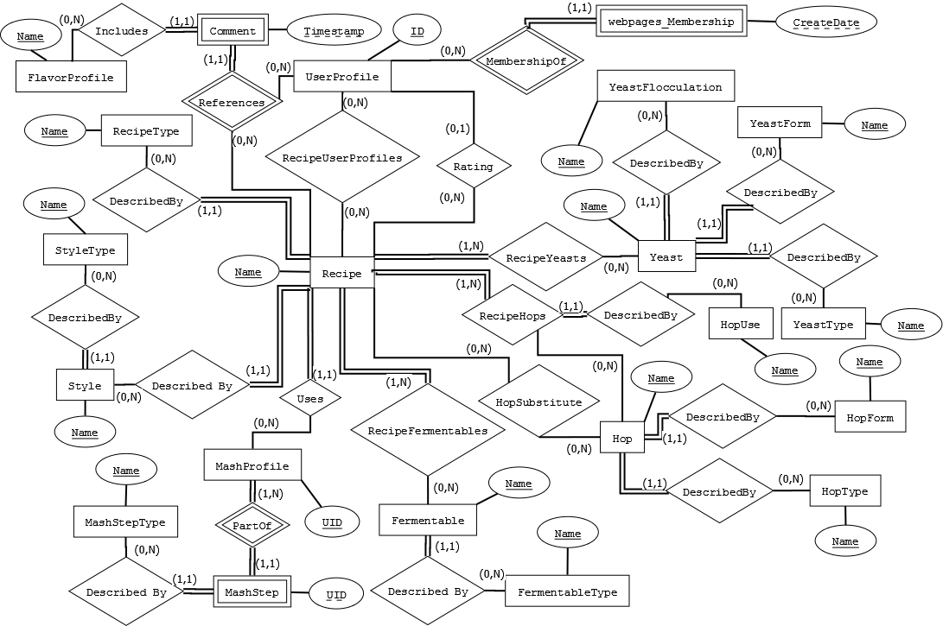
It should be noted here that this diagram ignores non-key entity attributes in order to somewhat simplify the diagram; it focuses instead on revealing the cardinalities and participation of the entities and their relationships across the entire database design. In the upcoming sections, logically grouped entities and relationships will be examined in more detail, with their attributes fully exploded and their mappings to the resulting database schema revealed.
UserProfile Details with Supporting Entities and Relationships
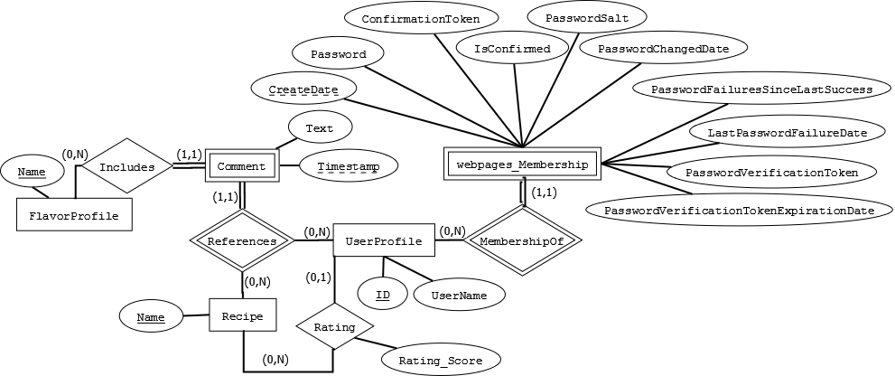
This diagram shows the details of entities and relationships which were mapped into the following partial schema definition:
FlavorProfile(Name)
UserProfile(ID, UserName)
Rating(Recipe_Name, UserProfile_UserID, Rating_Score)
Comment(Recipe_Name, UserProfile_UserID, Timestamp, Text, FlavorProfile_Name)
webpages_Membership(UserId, CreateDate, ConfirmationToken, IsConfirmed, LastPasswordFailureDate, PasswordFailuresSinceLastSuccess, Password, PasswordChangedDate, PasswordSalt, PasswordVerificationToken, PasswordVerificationTokenExpirationDate)
Hop Details with Supporting Entities and Relationships
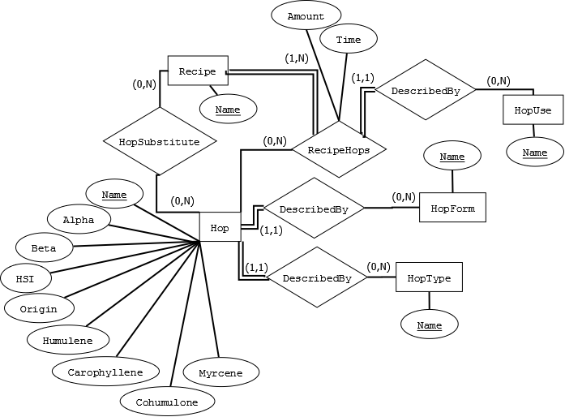
This diagram shows the details of entities and relationships which were mapped into the following partial schema definition:
HopUse(Name)
HopForm(Name)
HopType(Name)
RecipeHops(Recipe_Name, Hop_Name, HopUses_Name, Amount, Time)
HopSubstitute(Hop_Name, Recipe_Name)
Hop(Name, Alpha, Beta, HSI, Origin, Humulene, Caryophyllene, Cohumulone, Myrcene, HopForm_Name, HopType_Name)

Fermentable Details with Supporting Entities and Relationships
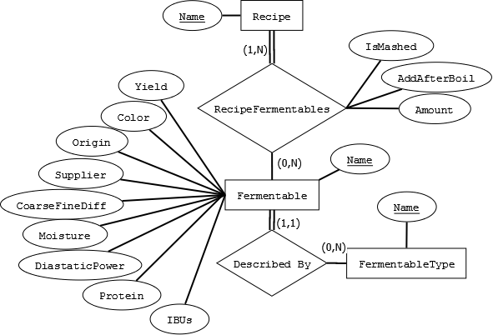
This diagram shows the details of entities and relationships which were mapped into the following partial schema definition:
FermentableType(Name)
RecipeFermentables(Recipe_Name, Fermentable_Name, IsMashed, AddAfterBoil, Amount)
Fermentable(Name, Yield, Color, Origin, Supplier, CoarseFineDiff, Moisture, DiastaticPower, Protein, IBUs, FermentableType_Name)

Yeast Details with Supporting Entities and Relationships
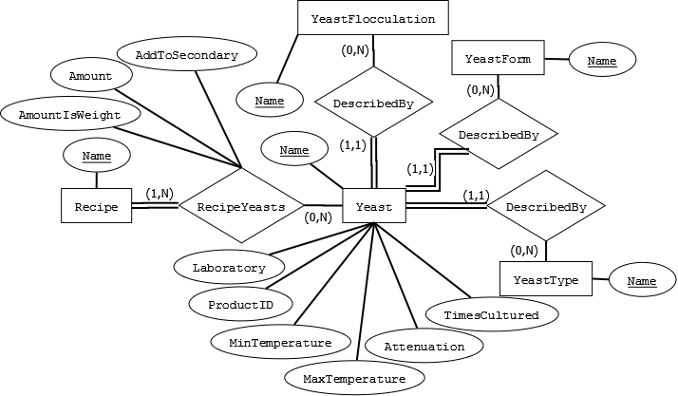
This diagram shows the details of entities and relationships which were mapped into the following partial schema definition:
YeastForm(Name)
YeastType(Name)
YeastFlocculation(Name)
RecipeYeasts(Recipe_Name, Yeast_Name, AddToSecondary, Amount, AmountIsWeight)
Yeast(Name, Laboratory, ProductID, MinTemperature, MaxTemperature, Attenuation, TimesCultured, YeastType_Name, YeastFlocculation_Name, YeastForm_Name)

Style Details with Supporting Entities and Relationships
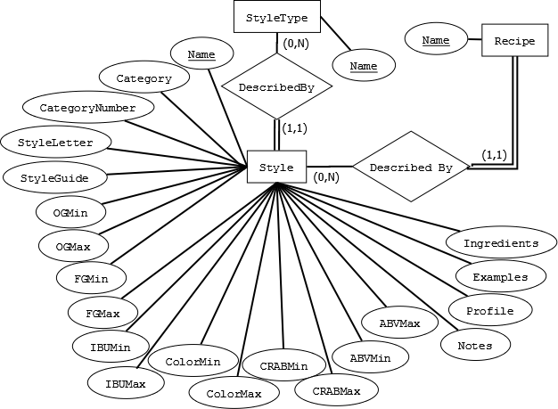
This diagram shows the details of entities and relationships which were mapped into the following partial schema definition:
StyleType(Name)
Style(Name, Category, CategoryNumber, StyleLetter, StyleGuide, OGMin, OGMax, FGMin, FGMax, IBUMin, IBUMax, ColorMin, ColorMax, CRABMin, CRABMax, ABVMin, ABVMax, Notes, Profile, Ingredients, Examples, StyleType_Name)

MashProfile Details with Supporting Entities and Relationships
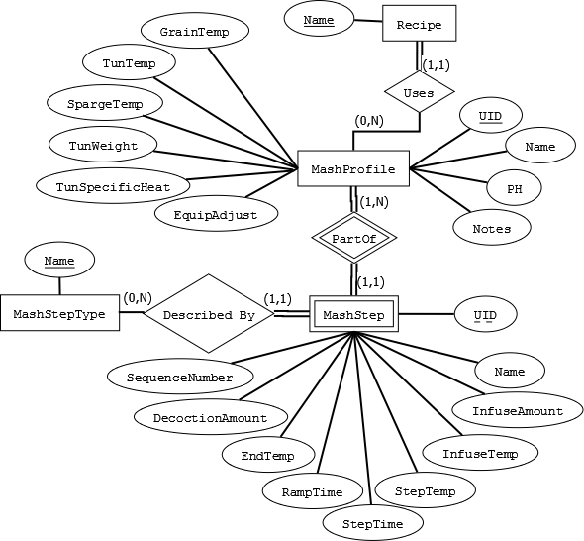
This diagram shows the details of entities and relationships which were mapped into the following partial schema definition:
MashStepType(Name)
MashStep(MashProfile_UID, UID, Name, InfuseAmount, StepTemp, StepTime, RampTime, EndTemp, InfuseTemp, DecoctionAmount, SequenceNumber, MashStepType_Name)
MashProfile(UID, Name, GrainTemp, Notes, TunTemp, SpargeTemp, PH, TunWeight, TunSpecificHeat, EquipAdjust)

Recipe Details with Supporting Entities, Relationships
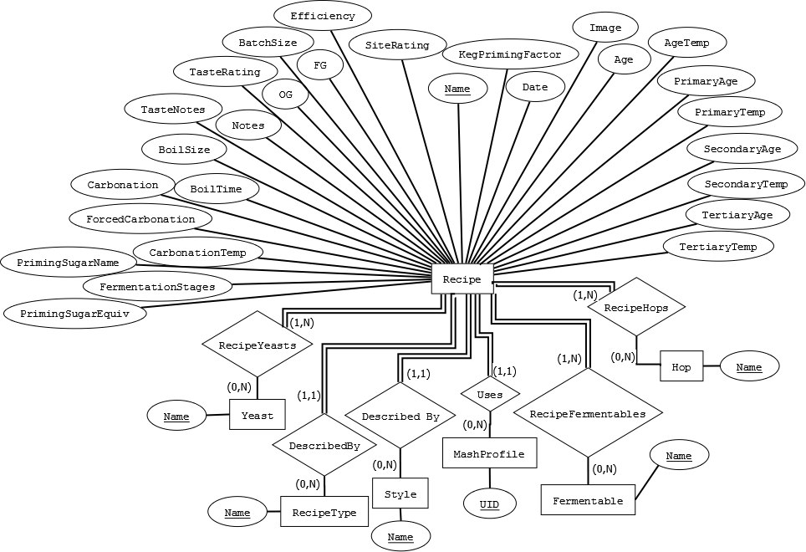
This diagram shows the details of entities and relationships which were mapped into the following partial schema definition:
RecipeType(Name)
Recipe(Name, BatchSize, BoilSize, BoilTime, Efficiency, Notes, TasteNotes, TasteRating, OG, FG, FermentationStages, PrimaryAge, PrimaryTemp, SeconaryAge, SecondaryTemp, TertiaryAge, TertiaryTemp, Age, AgeTemp, Date, Carbonation, ForcedCarbonation, PrimingSugarName, CarbonationTemp, PrimingSugarEquiv, KegPrimingFactor, SiteRating, Image, RecipeType_Name, Style_Name, Mash_UID)
Tying it All Together: The Complete Schema
FlavorProfile(Name)
UserProfile(ID, UserName)
RecipeUserProfiles(Recipe_Name, UserProfile_UserId)
Rating(Recipe_Name, UserProfile_UserID, Rating_Score)
Comment(Recipe_Name, UserProfile_UserID, Timestamp, Text, FlavorProfile_Name)
webpages_Membership(UserId, CreateDate, ConfirmationToken, IsConfirmed, LastPasswordFailureDate, PasswordFailuresSinceLastSuccess, Password, PasswordChangedDate, PasswordSalt, PasswordVerificationToken, PasswordVerificationTokenExpirationDate)
HopUse(Name)
HopForm(Name)
HopType(Name)
RecipeHops(Recipe_Name, Hop_Name, HopUses_Name, Amount, Time)
HopSubstitute(Hop_Name, Recipe_Name)
Hop(Name, Alpha, Beta, HSI, Origin, Humulene, Caryophyllene, Cohumulone, Myrcene, HopForm_Name, HopType_Name)
FermentableType(Name)
RecipeFermentables(Recipe_Name, Fermentable_Name, IsMashed, AddAfterBoil, Amount)
Fermentable(Name, Yield, Color, Origin, Supplier, CoarseFineDiff, Moisture, DiastaticPower, Protein, IBUs, FermentableType_Name)
YeastForm(Name)
YeastType(Name)
YeastFlocculation(Name)
RecipeYeasts(Recipe_Name, Yeast_Name, AddToSecondary, Amount, AmountIsWeight)
Yeast(Name, Laboratory, ProductID, MinTemperature, MaxTemperature, Attenuation, TimesCultured, YeastType_Name, YeastFlocculation_Name, YeastForm_Name)
StyleType(Name)
Style(Name, Category, CategoryNumber, StyleLetter, StyleGuide, OGMin, OGMax, FGMin, FGMax, IBUMin, IBUMax, ColorMin, ColorMax, CRABMin, CRABMax, ABVMin, ABVMax, Notes, Profile, Ingredients, Examples, StyleType_Name)
MashStepType(Name)
MashStep(MashProfile_UID, UID, Name, InfuseAmount, StepTemp, StepTime, RampTime, EndTemp, InfuseTemp, DecoctionAmount, SequenceNumber, MashStepType_Name)
MashProfile(UID, Name, GrainTemp, Notes, TunTemp, SpargeTemp, PH, TunWeight, TunSpecificHeat, EquipAdjust)
RecipeType(Name)
Recipe(Name, BatchSize, BoilSize, BoilTime, Efficiency, Notes, TasteNotes, TasteRating, OG, FG, FermentationStages, PrimaryAge, PrimaryTemp, SeconaryAge, SecondaryTemp, TertiaryAge, TertiaryTemp, Age, AgeTemp, Date, Carbonation, ForcedCarbonation, PrimingSugarName, CarbonationTemp, PrimingSugarEquiv, KegPrimingFactor, SiteRating, Image, RecipeType_Name, Style_Name, Mash_UID)
The Schema Relations with their Constraints
Relation: FlavorProfile | Name
Domain Constraints: | nvarchar[50]
Attribute Constraints: | None
Primary Key? | Yes
Foreign Key? | No

Relation: UserProfile | ID | UserName
Domain Constraints: | int
Attribute Constraints: | None
Primary Key? | Yes | No
Foreign Key? | No | Yes, to UserProfile.ID

Relation: RecipeUserProfiles | Recipe_Name | UserProfile_UserId
Domain Constraints: | nvarchar[75] | int
Attribute Constraints: | None | None
Primary Key? | Yes | Yes
Foreign Key? | Yes, to Recipe.Name | Yes, to UserProfile.ID

Relation: Rating | Recipe_Name | UserProfile_UserID | Rating_Score
Domain Constraints: | nvarchar[75] | int | int
Attribute Constraints: | None | None | 1 <= value <= 10
Primary Key? | Yes | Yes | No
Foreign Key? | Yes, to Recipe.Name | Yes, to UserProfile.ID | No

Relation: Comment | Recipe_Name | UserProfile_UserID | Timestamp | Text | FlavorProfile_Name
Domain Constraints: | nvarchar[75] | int | datetime | nvarchar[250] | nvarchar[50]
Attribute Constraints: | None | None | None | None | None
Primary Key? | Yes | Yes | Yes | No | No
Foreign Key? | Yes, to Recipe.Name | Yes, to UserProfile.ID | No | No | Yes, to FlavorProfile.Name

Relation: webpages_Membership | UserId | CreateDate | ConfirmationToken | IsConfirmed
Domain Constraints: | int | datetime | nvarchar[128] | bit
Attribute Constraints: | None | None | None | None
Primary Key? | Yes | Yes | No | No
Foreign Key? | Yes, to UserProfile.ID | No | No | No
 | LastPasswordFailureDate | PasswordFailuresSinceLastSucces | Password | PasswordChangedDate
Domain Constraints: | datetime | int | nvarchar[128] | datetime
Attribute Constraints: | None | None | None | None
Primary Key? | No | No | No | No
Foreign Key? | No | No | No | No
 | PasswordSalt | PasswordVerificationToken | PasswordVerificationTokenExpirationDate
Domain Constraints: | nvarchar[128] | nvarchar[128] | nvarchar[128] | datetime
Attribute Constraints: | None | None | None | None
Primary Key? | No | No | No | No
Foreign Key? | No | No | No | No

Relation: HopUse | Name
Domain Constraints: | nvarchar[75]
Attribute Constraints: | None
Primary Key? | Yes
Foreign Key? | No

Relation: HopForm | Name
Domain Constraints: | nvarchar[75]
Attribute Constraints: | None
Primary Key? | Yes
Foreign Key? | No

Relation: HopType |  | Name
Domain Constraints: |  | nvarchar[75]
Attribute Constraints: |  | None
Primary Key? |  | Yes
Foreign Key? |  | No
Relation: RecipeHops | Recipe_Name |  |  | Hop_Name | HopUses_Name | Amount | Time
Domain Constraints: | nvarchar[75] |  |  | nvarchar[75] | nvarchar[75] | real | real
Attribute Constraints: | None |  |  | None | None | None | None
Primary Key? | Yes |  |  | Yes | No | No | No
Foreign Key? | Yes, to Recipe.Name |  |  | Yes, to Hop.Name | Yes, to HopUes.Name | No | No

Relation: HopsSubstitute | Hop_Name | Recipe_Name
Domain Constraints: | nvarchar[75] | nvarchar[75]
Attribute Constraints: | None | None
Primary Key? | Yes | Yes
Foreign Key? | Yes, to Hop.Name | Yes, to Recipe.Name

Relation: Hop | Name | Alpha | Beta | HSI | Origin
Domain Constraints: | nvarchar[75] | real | real | real | nvarchar[75]
Attribute Constraints: | None | None | None | None | None
Primary Key? | Yes | No | No | No | No
Foreign Key? | No | No | No | No | No
 | Humulene | Caryophyllene | Cohumulone | Myrcene | HopForm_Name | HopType_Name
Domain Constraints: | real | real | real | real | nvarchar[75] | nvarchar[75]
Attribute Constraints: | None | None | None | None | None | None
Primary Key? | No | No | No | No | No | No
Foreign Key? | No | No | No | No | Yes, to HopForm.Name | Yes, to HopType.Name

Relation: FermentableType | Name
Domain Constraints: | nvarchar[75]
Attribute Constraints: | None
Primary Key? | Yes
Foreign Key? | No

Relation: RecipeFermentables | Recipe_Name | Fermentable_Name | IsMashed | AddAfterBoil | Amount
Domain Constraints: | nvarchar[75] | nvarchar[75] | bit | bit | real
Attribute Constraints: | None | None | None | None | None
Primary Key? | Yes | Yes | No | No | No
Foreign Key? | Yes, to Recipe.Name | Yes, to Fermentable.Name | No | No | No

Relation: Fermentable | Name | Yield | Color | Origin | Supplier
Domain Constraints: | nvarchar[75] | real | real | nvarchar[75] | nvarchar[75]
Attribute Constraints: | None | None | None | None | None
Primary Key? | Yes | No | No | No | No
Foreign Key? | No | No | No | No | No
 | CoarseFineDiff | Moisture | DiastaticPower | Protein | IBUs | FermentableType_Name
Domain Constraints: | real | real | real | real | real | nvarchar[75]
Attribute Constraints: | None | None | None | None | None | None
Primary Key? | No | No | No | No | No | No
Foreign Key? | No | No | No | No | No | Yes, to FermentableType.Name

Relation: YeastForm | Name
Domain Constraints: | nvarchar[75]
Attribute Constraints: | None
Primary Key? | Yes
Foreign Key? | No

Relation: YeastType | Name
Domain Constraints: | nvarchar[75]
Attribute Constraints: | None
Primary Key? | Yes
Foreign Key? | No

Relation: YeastFlocculation | Name
Domain Constraints: | nvarchar[75]
Attribute Constraints: | None
Primary Key? | Yes
Foreign Key? | No

Relation: RecipeYeasts | Recipe_Name | Yeast_Name | AddToSecondary | Amount | AmountIsWeight
Domain Constraints: | nvarchar[75] | nvarchar[75] | bit | real | bit
Attribute Constraints: | None | None | None | None | None
Primary Key? | Yes | Yes | No | No | No
Foreign Key? | Yes, to Recipe.Name | Yes, to Yeast.Name | No | No | No

Relation: Yeast | Name | Laboratory | ProductID | MinTemperature | MaxTemperature
Domain Constraints: | nvarchar[75] | nvarchar[75] | int | real | real
Attribute Constraints: | None | None | None | None | None
Primary Key? | Yes | No | No | No | No
Foreign Key? | No | No | No | No | No
 | Attenuation | TimesCultured | YeastType_Name | YeastFlocculation_Name | YeastForm_Name
Domain Constraints: | real | int | nvarchar[75] | nvarchar[75] | nvarchar[75]
Attribute Constraints: | None | None | None | None | None
Primary Key? | No | No | No | No | No
Foreign Key? | No | No | Yes, to YeastType.Name | Yes, to YeastFlocculation.Name | Yes, to YeastForm.Name

Relation: StyleType | Name
Domain Constraints: | nvarchar[75]
Attribute Constraints: | None
Primary Key? | Yes
Foreign Key? | No

Relation: MashStepType | Name
Domain Constraints: | nvarchar[75]
Attribute Constraints: | None
Primary Key? | Yes
Foreign Key? | No

Relation: Style | Name | Category | CategoryNumber | StyleLetter | StyleGuide
Domain Constraints: | nvarchar[75] | nvarchar[75] | nvarchar[-1] | nvarchar[1] | nvarchar[-1]
Attribute Constraints: | None | None | None | None | None
Primary Key? | Yes | No | No | No | No
Foreign Key? | No | No | No | No | No
 | OGMin | OGMax | FGMin | FGMax | IBUMin | IBUMax
Domain Constraints: | real | real | real | real | real | real
Attribute Constraints: | None | None | None | None | None | None
Primary Key? | No | No | No | No | No | No
Foreign Key? | No | No | No | No | No | No
 | ColorMin | ColorMax | CRABMin | CRABMax | ABVMin | ABVMax
Domain Constraints: | real | real | real | real | real | real
Attribute Constraints: | None | None | None | None | None | None
Primary Key? | No | No | No | No | No | No
Foreign Key? | No | No | No | No | No | No
 | Notes | Profile | Ingredients | Examples | StyleType_Name
Domain Constraints: | nvarchar[-1] | nvarchar[-1] | nvarchar[-1] | nvarchar[-1] | nvarchar[75]
Attribute Constraints: | None | None | None | None | None
Primary Key? | No | No | No | No | No
Foreign Key? | No | No | No | No | Yes, to StyleType.Name

Relation: MashProfile | UID | Name | GrainTemp | Notes | TunTemp
Domain Constraints: | int | nvarchar[75] | real | nvarchar[-1] | real
Attribute Constraints: | None | None | None | None | None
Primary Key? | Yes | No | No | No | No
Foreign Key? | No | No | No | No | No
 | SpargeTemp | PH | TunWeight | TunSpecificHeat | EquipAdjust
Domain Constraints: | real | real | real | real | bit
Attribute Constraints: | None | None | None | None | None
Primary Key? | No | No | No | No | No
Foreign Key? | No | No | No | No | No

Relation: MashStep | MashProfile_UID | UID | Name | InfuseAmount | StepTemp | StepTime
Domain Constraints: | int | int | nvarchar[75] | real | real | real
Attribute Constraints: | None | None | None | None | None | None
Primary Key? | Yes | Yes | No | No | No | No
Foreign Key? | Yes, to MashProfile.UID | No | No | No | No | No
 | RampTime | EndTemp | InfuseTemp | DecoctionAmount | SequenceNumber | MashStepType_Name
Domain Constraints: | real | real | real | real | int | nvarchar[75]
Attribute Constraints: | None | None | None | None | None | None
Primary Key? | No | No | No | No | No | No
Foreign Key? | No | No | No | No | No | Yes, to MashStepType.Name

Relation: RecipeType | Name
Domain Constraints: | nvarchar[75]
Attribute Constraints: | None
Primary Key? | Yes
Foreign Key? | No

Relation: Recipe | Name | BatchSize | BoilSize | BoilTime | Efficiency | Notes
Domain Constraints: | nvarchar[75] | real | real | real | real | nvarchar[-1]
Attribute Constraints: | None | None | None | None | None | None
Primary Key? | Yes | No | No | No | No | No
Foreign Key? | No | No | No | No | No | No
 | TasteNotes | TasteRating | OG | FG | FermentationStages | PrimaryAge
Domain Constraints: | nvarchar[-1] | real | real | real | int | real
Attribute Constraints: | None | None | None | None | None | None
Primary Key? | No | No | No | No | No | No
Foreign Key? | No | No | No | No | No | No
 | PrimaryTemp | SecondaryAge | SecondaryTemp | TertiaryAge | TertiaryTemp | Age
Domain Constraints: | real | real | real | real | real | real
Attribute Constraints: | None | None | None | None | None | None
Primary Key? | No | No | No | No | No | No
Foreign Key? | No | No | No | No | No | No
 | AgeTemp | Date | Carbonation | ForceCarbonation | PrimingSugarName | CarbonationTemp
Domain Constraints: | real | datetime | real | bit | nvarchar[75] | bit
Attribute Constraints: | None | None | None | None | None | None
Primary Key? | No | No | No | No | No | No
Foreign Key? | No | No | No | No | No | No
 | PrimingSugarEquiv | KegPrimingFactor | SiteRating | Image | RecipeType_Name | Style_Name | Mash_UID
Domain Constraints: | nvarchar[75] | real | real | real | real | varbinary[-1] | int
Attribute Constraints: | None | None | None | None | None | None | None
Primary Key? | No | No | No | No | No | No | No
Foreign Key? | No | No | No | No | Yes, to RecipeType.Name | Yes, to Style.Name | Yes, to Mash.UID

MVC ASP Model Class Definitions and their Create Table Statements
In ASP MVC with Microsoft Visual Studio’s Entity Framework (EF) database tables are created by first defining the “model” classes which will represent them in the server code, and then performing a “code-first migration” to generate create table and alter table statements for the underlying SQL database (although these statements must often be edited for correctness by the programmer). This section provides both the model class definitions and their corresponding MVC SQL table create statements (in their final, corrected form) for each of the relations in the implemented application database.
<TBD>
User Interface [Michael Grenon]
Hoppin Brew Social requires an intuitive flexible UI to attract enthusiasts to use. The enthusiasts can store an image and Username to the site to represent themselves. TODO? Non users can search for beer recipe by Username to know how active people are and find users who have the same tastes for beer that they have. The site allows users to look through recipe ingredients to identify beers for which they already have the makings for. The site provides users the operations to edit and create new recipes.

Intro Page – Sortable Recipe List [Michael Grenon]
Some cool information about the sortable recipe list and how you don’t even have to be logged in to see it.
Figure 1. Chi Squared algorithm.
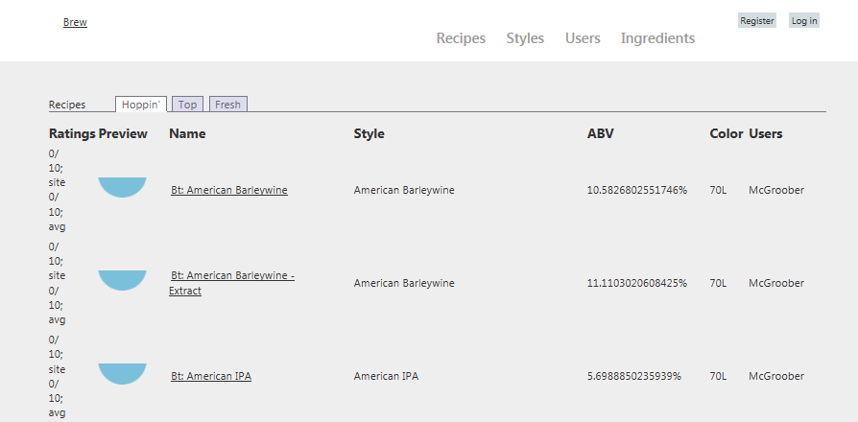

Styles UI [Michael Grenon]
Some screen shots and cool stuff about the styles page.

User Login and Registration [Caleb Simmons]
Once an individual decides to contribute to Hoppin’ Brew Social they must become a member. Members can log in using the User Login UI to submit their User Name and Password as shown in the screenshot on Figure 2. The User Login UI allows users to store a cookie with the site to remember the user’s login information after the “Remember me?” checkbox is selected. A link to the register page is available from this page for when the individual does not yet have an account.
Figure 2. Hoppin’ Log in
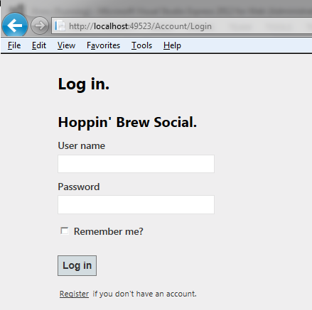
User Management for Hoppin’ Brew Social requires a user name for identification and password with confirmation. Once a user is registered they are automatically flagged as confirmed and are able to immediately log in to start contributing.
Figure 3. Hoppin’ User Management
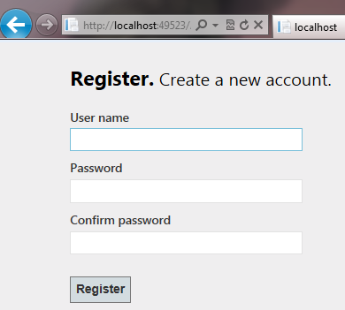

Editor UI [Michael Grenon]
Some screen shots and cool stuff about the editors for hops, fermentables, yeasts, etc.

Flavor Wheel [James Glass]
A “flavor wheel” is a graphical depiction of the terms most commonly used to describe the flavor of beer amongst brewing enthusiasts. Several variations on this concept have sprouted up in recent years; this application’s version is adapted from the freely-available and most popular version of this concept, which has come to gain widespread recognition and use in the online brewing enthusiast community.
A programmable version of the flavor wheel concept has been implemented in the UI of this application using Javascript and an HTML 5 canvas element for use in displaying the Hoppin’ Brew Social web site community’s collective description of the flavor of beer resulting from a particular recipe. When users leave comments on a recipe, they also supply one of a defined set of “flavor profiles,” each of which represents one of the descriptive terms located on the outer tier of the flavor wheel; the user’s flavor profile selection is then stored with the comment record in the database.
When a user loads a page containing a flavor wheel instance, the server queries the database to obtain a list of all comment records associated with the recipe which the flavor wheel instance will be used to describe. The records are then used to calculate percentage values for each flavor profile present in the comments; these percentages represent the proportion of comments which reference a given flavor profile to the overall comment count for this recipe. The percentages are then used as inputs to a basic Barycentric interpolation operation to obtain the interpolated color value between the flavor wheel’s default “off” color (a muted light gray), and the “on” color of the flavor profile’s designated section in the flavor wheel graphic.
As the inner tiers’ sections on the flavor wheel represent categories into which the outer tier’s flavor profiles may be logically grouped, they aggregate the percentages of their “child” flavor profile sections to determine their own interpolation inputs. Thus, the percentages of each of the tiers of the flavor wheel graphic sum to 100%, providing an intuitive graphical depiction of the “flavor” of brews produced by a given recipe, as reported by the community.
The figure below shows a screen capture of the flavor wheel for a “barleywine” recipe:
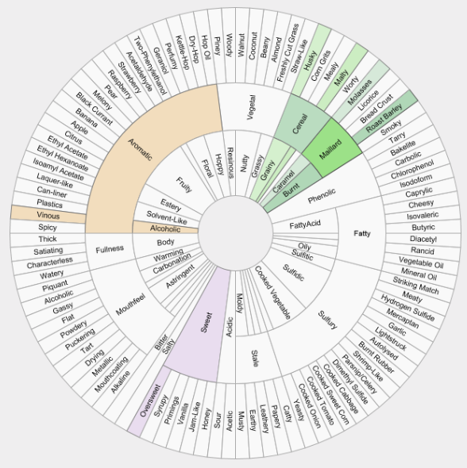
The flavor wheel is a visual component common to both the Recipe Details UI and the Recipe Comments UI.

Application Overview [Michael Grenon & Caleb Simmons]
The application is hosted locally on Internet Information Services which executes on the .Net framework through the Windows operating system. The application was developed using Visual Studio 20012 for Web using MVC with Razor in C#. The application communicates to the Microsoft Database File using Entity Framework Code First.

Implementation Overview
The architecture of Hoppin’ Brew Social is best described by the tiered design pattern common to web applications. The database is connected to the application through a SqlClient connection that only communicates with the models described using the Entity Framework attributes. The Entity Framework Model tier communicates with the BeerXML parser as a standalone application/script. The Entity Framework Models also communicate with the Views through the abstraction of View Models which serve only to separate the dependency on the Entity Framework from the views. The View Model enabled development of the views to happen in parallel with the development of the Entity Framework Model tier. The Controllers work with the View Models to populate Views. This aspect of the application architecture is best described by the Model View Controller design pattern. The application architecture is represented as a block diagramed in Figure #.
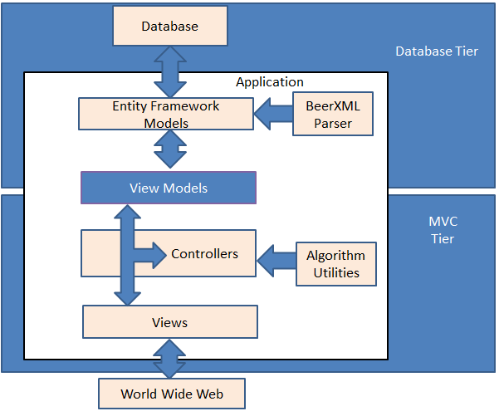

Algorithms Implementations [James Glass]
List out and describe the cool algorithms. Reference some figure showing pseudo code.
Figure 4. Pseudo code for ProcessImagePairs.java
Allocate Histogram Array for Image0 and Image1
Assume that Image0.size == Image1.size
brightnessChi, totalBrightness, saturationChi = 0
For x: 0 to Height

Meeting Minutes [Caleb Simmons]
Detailed notes were captured for each official team meeting described in the table below. Beyond the meetings, over 20 emails were sent and several 30+ minute Skype conversations concerning project development took pace.
Date/Time | Location | Attendees | Duration [Minutes] | Topic / Discussion Details
2/4/13 6:55 | UAH | All | 20 | Database environment options. SQLite, Compact, and Microsoft Database File were suggested and we chose Microsoft Database File.  Programming environment options. Team narrowed the options to C# ASP.net classic and MVC. James took the action item of investigating MVC.  Source Control options. Team decided to use GitHub so each member had to create an account on GitHub.  Michael suggested BeerXML as a source for populating the database with realistic information so Caleb as the database lead took the action item of investigating that.
2/11/13 6:55 | UAH | All | 20 | Michael suggested that Entity Framework be used to generate the database using Code First. Caleb took the action item to investigate Code First.  Discussed how to handle enumerations in the database. Michael suggested that Entity Framework might support it and Caleb took the action item to investigate.  Michael took the action item to create an initial project setup for the git repository.  Goal for next meeting is for all team members to draft potential view ideas. And to follow the MVC tutorials online.
2/18/13 6:55 | UAH | All | 20 | James presented the design of a view component called “Beer Flavor Wheel” which allowed users to have a graphical representation for the flavor of a beer.  Michael presented designs for the sortable tabbed home page and recipe edit pages.  Caleb came up with the name “Hoppin’ Brew Social” and suggested that the columns be sorted by most “Hoppin’”.
3/13/13 6:55 | UAH | All | 10 | Caleb decided that he would use Entity Framework for connecting the database to the application code.  Michael suggested that he could start implementation of the views by separating the view model from the database model.  James continued implementation of the Flavor Wheel.  Caleb took the action item to present database schema draft.
4/1/13 6:55 | UAH | All | 5 | Caleb presented the schema draft and took the action item to implement the schema and parse the beerXML into it.  Michael took the action item of sending Caleb beerXML information.
4/3/13 6:55 | UAH | All | 15 | James took the responsibility of formatting and managing the report over all.  Caleb took the action item to write the database portion of the report. Caleb also agreed to create a user management and login page for the application.  Michael continued work on the application views.
4/8/13 6:55 | UAH | All | 15 | Team each volunteered responsibility for sections of the report.  Caleb presented an updated schema of the database.  James suggested that a comment table be added and that Amount should be move to the join tables.  Michael suggested that the isMashed, isSecondary, and HopUse be moved to the join tables.  James took the action item of creating a the ER diagram.

Example brew recipe data obtained from the “BeerXML” standardized recipe description document accompanying the open-source brew recipe editor program “Brewtarget”, version 2.0.1, available at (www.brewtarget.org)
A static image version is freely available for download and distribution at (www.beerflavorwheel.com)

